Assignment 1: Spectral analysis of EEG

Johannes Mämmelä
150207782
johannes.mammela@tuni.fi

- Introduction
An electroencelogram (EEG) is a test that measures electrical activity in the brain using small electrodes attached to the scalp. Brain cells are active all the time and communicate with electrical impulses. So, the potential difference between two electrodes can be measured. In typical EEG recording 20 electrodes is located around the head to get a precise visualization of brain activity. This activity presents as a wavy line on a EEG recordings. [1]
EEG measures the voltage difference by function of time. From the raw signal, certain peaks like eye closing and opening can be distinguished but frequency distribution is very important part of analysis and diagnosing too. The frequency information is divided to four types of waves (alpha 8-13Hz, beeta >13Hz, theta 4-8Hz and delta <4Hz). EEG measurement has an important role in finding various illnesses for example epilepsy diagnosing. When EEG shows interictal epileptiform discharges like sharp waves, spikes or spike and wave are confirmatory of epilepsy with high specificity. [2]
In this exercise, EEG data has measured with three electrodes and the aim of the exercise is to analyse the frequency distribution of it with different kind of methods and study the effect of command parameters to the spectrum.

- Methods
Time domain signal can be changed to frequency domain with Welch method. Welch method creates the Power Spectral Density Estimate (PSD) of the signal. It transforms the time domain signal to frequency domain with Fast Fourier transform. Welch function estimates the PSD by dividing the data to smaller windows and calculates the power spectrums of these. So, as a result, it gives a power of the signal at the certain frequency. The operation of the function can be adjusted by changing the window size, overlapping of the windows and the number of discrete points of the Fourier transform. These are the parameters of the command. [3]
Another method is to plot spectrogram. It uses the same parameters than Welch method has and does the discrete Fourier transform but as a result it gives the visualization of frequencies by function of time and shows different powers per frequency in different colours.

- Results
Raw measurement data is presented in figure 1. As will be seen it is so hard to read because there is so many samples and data bounces up and down with so big density. From that figure we cannot say anything, but the amplitude cap looks like correct.
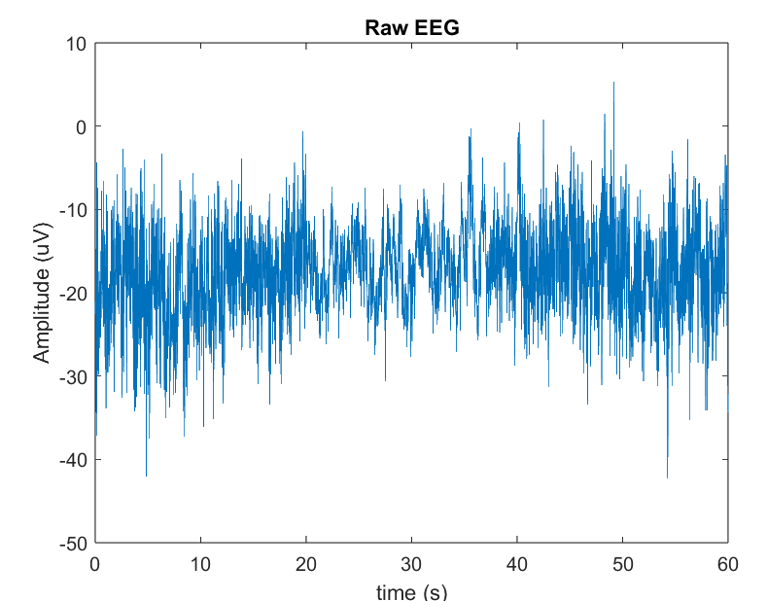
Figure 1: Raw data
Power Spectrum Estimates with two different sets of parameters have been presented in figures 2 and 3. In figure 2, used parameters are twice as big as in figure 3.
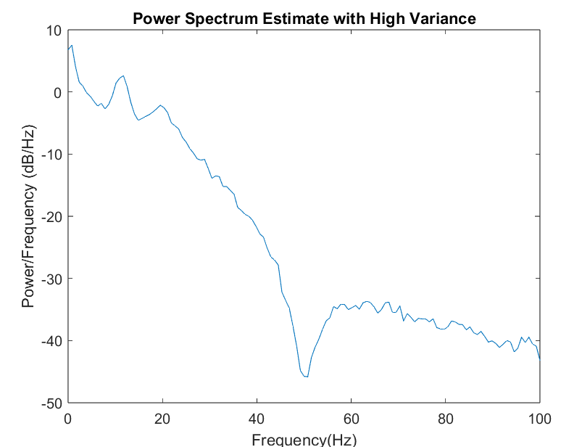
Figure 2: PSD with window size 256, overlap 128 and number of DFT points 256
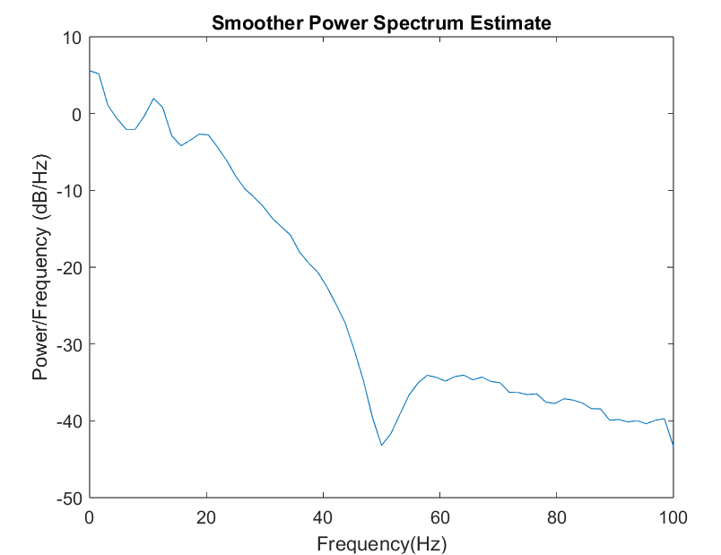
Figure 3: PSD with window size 128, overlap 64 and number of DFT points 128

By considering these two figures is noticed that the figure with lower parameter numbers is much smoother than figure with higher numbers. The window length effects the segment length of the signal. Larger window takes more points in one window so it gives more precise result than smaller window and that shows up as a more detailed line. On the other hand, smaller window is more sensitive to random peaks that might distort the outcome.
Overlap references the number of shared samples between windows. Larger overlap makes the segment more similar with “neighbour” windows because it uses more same samples but at the same time it might hide some important data.
Number of DFT points tells the number of signal segments. The more DFT points affect the higher resolution and more detailed outcome because the effect of one window is smaller compared to whole signal. Of course, higher number of DFT points also requires more computational time. Usually, the original signal has a huge number of samples so going through all of it is rough to computer and makes signals hard to read. If the number of DFT points is small, signal is smooth, but some important data might be lost, so it is important to find a suitable balance with it.

Spectrograms with the same parameters presented in figures 4 and 5. Signal with the high variance in figure 4 and with lower variance in figure 5.
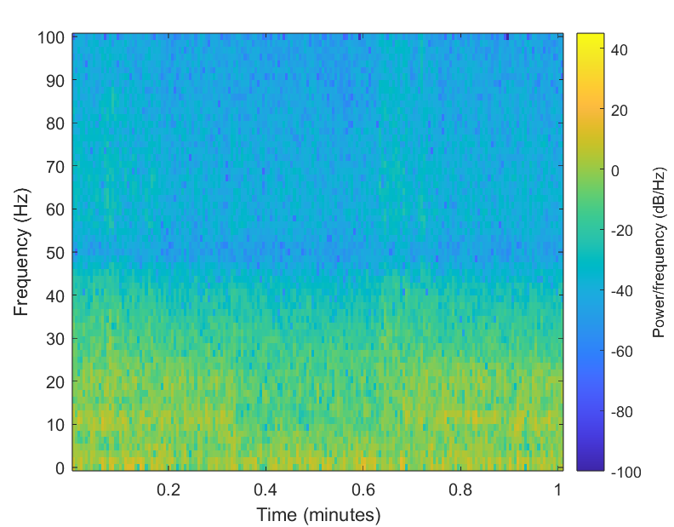
Figure 4: Spectrogram with window size 256, overlap 128 and number of DFT points 256

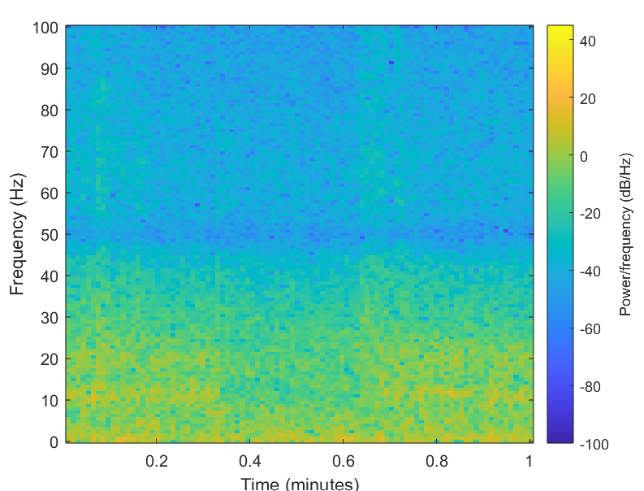
Figure 5: Spectrogram with window size 128, overlap 64 and number of DFT points 128

Considering pictures 4 and 5, it is noticeable that window size affects significantly to resolution of spectrogram. With larger window size, the resolution of figure is better than with smaller window size, but big changes distinguish better with lower resolution. Also, if the number of DFT points is smaller, data resolution is smaller and the fast changes do not distinguish so well.
By analysing those figures, there are also conspicuous blue line at the 50Hz. That means that the power is very low at the 50Hz frequency which is good thing because the 50Hz frequency comes from powerline interference and the device cuts it off very efficiently. However, there presents a lot of lower frequencies between 0-30Hz, where the brain rhythms are. By a closer look, it is seen that there is low power of frequencies around 10Hz between 20s to 40s. That time cap corresponds to time cap where eyes were open. When eyes are closed there should be more alpha waves because alpha waves are principal rest rhythm. So, the data looks correct.

- Stationarity
Stationarity means that signal´s statistical characteristics like mean and variance does not change over time. Biosignals like EEG are nonstationary signals because the brain activity changes over time depending on if we are foe example sleeping, resting of calculating physics. By looking those spectrograms, is seen that the frequency powers differs when eyes are open or closed, so we can say that measured data is nonstationary.
Welch method does not tell anything about stationarity because it does not give the outcome as a time-domain, so we cannot analyse it over time.

- Conclusion
In conclusion we can say that raw EEG-data is so disturbed and hard read. However, we have good analysing methods which are helping us in analysing. During measurement I learned to measure EEG at simple level and what thing affects to the measurement and the success off it. From this exercise I also learned to process biosignal data more and better. Specifically, Welch method was important to learn because I think it will be an important tool for me in future. Additionally, it was interesting how much different parameters affects to readability of figures.

6. Resources
[1] Mayo Clinic, “EEG (electroencelogram)” (2022), https://www.mayoclinic.org/tests-procedures/eeg/about/pac-20393875
[2] Wikipedia,” Electroencelogram”, https://en.wikipedia.org/wiki/Electroencephalography
[3] MathWorks HelpCenter, “pwelch”, https://se.mathworks.com/help/signal/ref/pwelch.html
[4] BBT.HTI.501, Processing of Biosignals, “General Assessment Criteria and Instructions for Assignments”, https://moodle.tuni.fi/pluginfile.php/3804357/mod_resource/content/3/BBT.HTI.501%20ComputerAssingment_General.pdf

- Matlab Codes

